# GATEBOX: PANEL USER MANUAL

By Shafeeq Rabbani

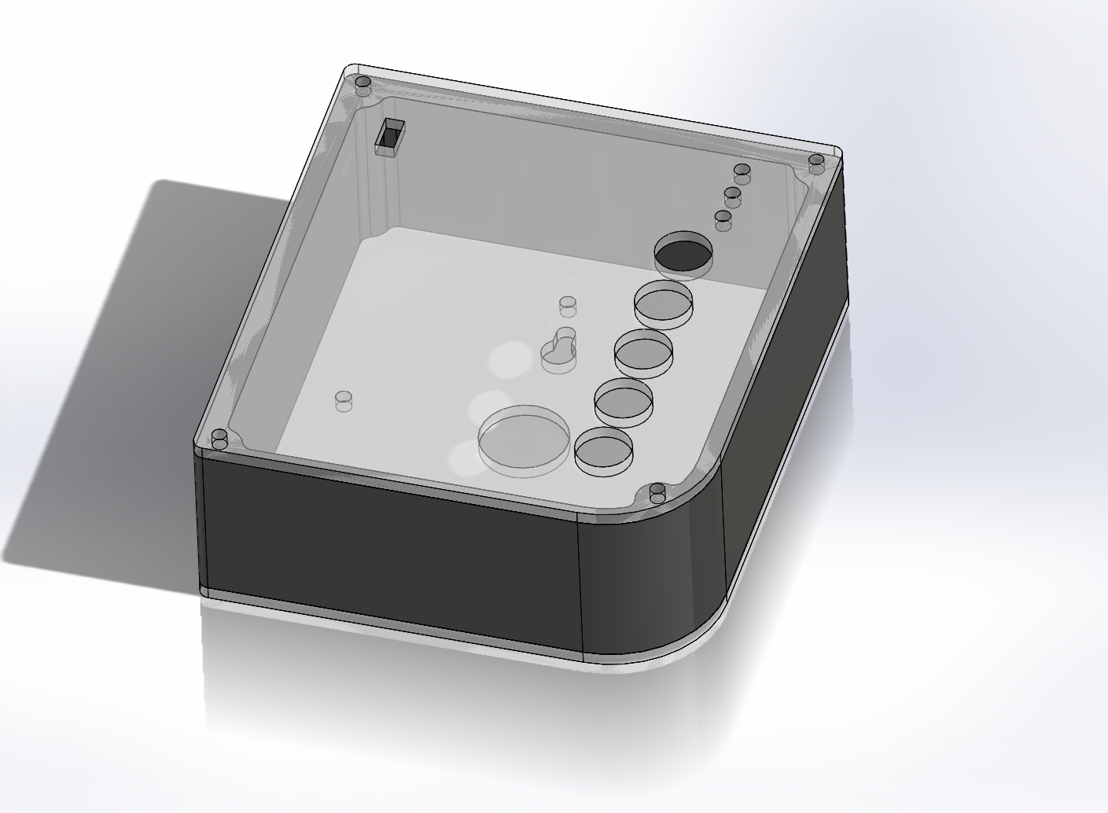

Green indicates Smartphone is connected to panel.

Yellow indicates panel is locked out.

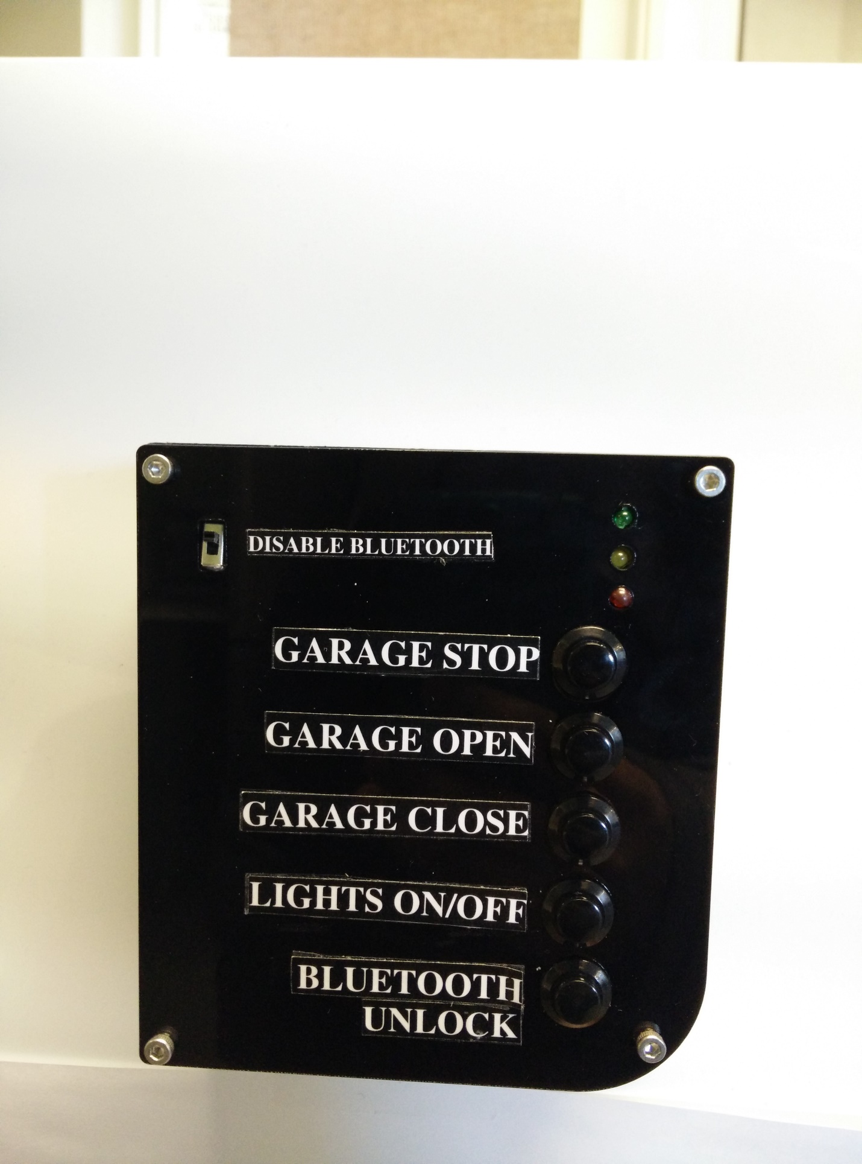

Red indicates no smartphone is connected to panel.

This button turns off the Bluetooth device. This feature is useful in the situation where the user is going on a vacation and does not want the GateBox panel’s Bluetooth login feature running during this time.

After 3 incorrect password attempts, the user is locked-out. The only way to reactivate wireless operation is by manually pressing the Bluetooth Unlock button.

Turn the lights On/Off

Close the Garage Door

Open the Garage Door

Stop the Garage Door